INTRODUCATION
Project Title: LearnMate - AI assistant for smarter learning and study support.

Team ID : SWTID-2026-8755
Team Leader : NETHRA SHREE S
Email: nethrashree90258@gmail.com
Team member :
- Nandhitha S
- Email:nandhithaskpc2024@gmail.com
- Nikitha U
- Email: nikithauma1234@gmail.com
3.Muskan J
- Email: muskanmuskan99865@gmail.com
4.Nisha S
- Email: sureshnisha2821@gmail.com
Description
LearnMate – AI Assistant for Smarter Learning and Study Support is an AI-powered learning platform designed to make studying easier and more effective for students. The system allows students to upload or provide their study materials and uses the Google Gemini AI API to generate concise summaries, flashcards, multiple-choice quizzes, and personalized study plans
The backend is developed using Node.js and Express.js with a RESTful API architecture. MongoDB is used to store user information, study materials, and AI-generated learning resources, while Mongoose is used for data modelling and database operations. The system uses JWT authentication, Role-Based Access Control (RBAC), and bcryptjs to provide secure access and protect user information.
Scenario-Based Case Study
Consider a college student who is preparing for semester examinations and placement-related activities. The student has study materials in different formats such as class notes, PDF files, textbooks, and online resources. Managing all these materials and preparing for examinations becomes difficult within a limited amount of time.
The student needs a simple system that can organize study materials and provide learning support. The proposed LearnMate system helps the student by using Artificial Intelligence to assist with learning activities. The student can provide study content and use the available features to support revision and examination preparation.
Problem
- Difficulty in understanding lengthy study materials.
- More time is required to prepare notes manually.
- Creating flashcards manually is repetitive.
- Preparing revision questions takes extra effort.
- Students may not have a proper personalized study plan.
- Study materials are stored in different places.
- Self-assessment through quizzes is difficult.
- Using multiple applications for studying reduces productivity.
Solution
• Provides a centralized platform for managing study materials.
• Uses AI to generate concise study summaries.
• Automatically creates flashcards for revision.
• Generates quizzes for self-assessment.
• Creates personalized study plans based on student requirements.
• Stores learning resources for future use.
• Provides secure user authentication and protected access.
• Reduces manual effort and saves study time.
Usage
Student Usage
Students can register and log in to the LearnMate application to access the learning features. After successful login, they can upload their study materials or provide the required study content. The system allows students to select different AI-based learning features such as summaries, flashcards, quizzes, and personalized study plans. The generated content can be viewed by the students and stored for future reference. This helps students organize their learning materials and support their examination preparation.
Administrator Usage
The administrator is responsible for managing the overall LearnMate system. The administrator can manage registered user accounts, monitor application activities, check AI service usage, review system logs, and maintain the proper functioning and security of the platform.

Outcome
The LearnMate system helps students improve their learning and revision process by providing AI-based educational support. It reduces the time required for preparing study resources and helps students organize their learning materials effectively.
The integration of AI, secure authentication, and MongoDB provides an efficient platform for generating and managing learning resources. The modular design also allows the system to be extended with additional learning features in the future.
Software Requirements
The software requirements for the LearnMate project are:
- Operating System: Windows 10/11, macOS, or Linux
- Node.js: Version 16 or above
- npm: Version 8 or above
- Express.js: For developing RESTful APIs
- MongoDB: For storing application data
- Postman: For API testing and verification
- Visual Studio Code: For developing and managing the project code
Hardware Requirements
The hardware requirements for the LearnMate project are:
- Processor: Intel Core i5 (8th Generation or above) / AMD Ryzen 5 or equivalent
- RAM: Minimum 8 GB; 16 GB recommended
- Storage: At least 1 GB of available storage space
Epic 1: Project Architecture
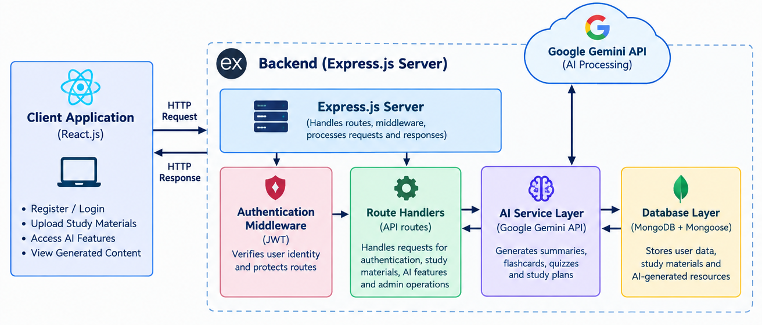
The LearnMate backend follows a modular RESTful architecture designed to provide secure, scalable, and AI-powered learning services. The system receives requests from the client application through the Express.js server, authenticates users using JWT, stores data in MongoDB, and communicates with the Google Gemini AI API to generate learning resources.
Components Definition
1. Client Application
The React.js frontend allows users to register, log in, upload study materials, and access AI-powered features through REST APIs.
2. Express Server
The Express.js server receives HTTP requests, handles routing and middleware, processes requests, and sends responses to the client.
3. Authentication Middleware
JWT-based authentication verifies the user's identity and protects private routes from unauthorized access.
4. Route Handlers
Routes manage API requests related to user authentication, study materials, AI features, and administrative operations.
5. AI Service Layer
The AI service communicates with the Google Gemini API to generate summaries, quizzes, flashcards, and personalized study plans.
6. Database Layer
MongoDB with Mongoose stores user information, uploaded study materials, and AI-generated learning resources.
Entity-Relationship (ER) Diagram Description
1. User Entity
The User Entity stores the details of registered students and administrators in the LearnMate system.
Attributes:
- _id – Primary Key (ObjectId)
- name – User's name
- email – User's email address
- password – Hashed password
- role – Student / Admin
2. Study Material Entity
The Study Material Entity stores the study content uploaded by students for AI processing.
Attributes:
- _id – Primary Key
- userId – Foreign Key → User
- title – Title of the study material
- subject – Subject name
- content – Study material content
- createdAt – Date and time of creation
3. Summary Entity
The Summary Entity stores the AI-generated summaries created from the study materials.
Attributes:
- _id – Primary Key
- userId – Foreign Key → User
- materialId – Foreign Key → Study Material
- summary – AI-generated summary
- createdAt – Date and time of creation
4. Flashcard Entity
- _id – Primary Key
- userId – Foreign Key → User
- materialId – Foreign Key → Study Material
- question – Flashcard question
- answer – Flashcard answer
- createdAt – Date and time of creation
5. Quiz Entity
The Quiz Entity stores the AI-generated quizzes created from the study materials. Each quiz contains multiple questions that help students test their understanding.
Attributes:
- _id – Primary Key
- userId – Foreign Key → User
- materialId – Foreign Key → Study Material
- questions – Quiz questions
- createdAt – Date and time of creation
6. Study Plan Entity
The Study Plan Entity stores personalized study schedules created for students. It helps users organize their learning activities based on their study requirements and generated plans.
Attributes:
- _id – Primary Key (ObjectId)
- userId – Foreign Key → User
- title – Name of the study plan
- tasks – List of study tasks
- createdAt – Date and time when the plan was created
Key Relationships
The main relationships between the entities in the AI StudyBuddy system are:
- User → Study Material
One user can create or upload multiple study materials.
- Study Material → Summary
A study material can have a generated summary.
- Study Material → Flashcard
A study material can generate multiple flashcards.
- Study Material → Quiz
A study material can generate quizzes for practice.
- User → Study Plan
A user can create multiple personalized study plans.
- User → Summary, Flashcard, Quiz
Generated learning resources are associated with the user who created them.
Key Features
The main features of the AI StudyBuddy system are:
- Secure Authentication – Uses JWT authentication and bcrypt password hashing.
- Study Material Management – Students can upload and manage their study materials.
- AI Summarization – Generates concise summaries from study materials.
- AI Flashcards – Creates question-and-answer flashcards for revision.
- AI Quiz Generation – Generates quizzes to help students test their knowledge.
- Personalized Study Plans – Creates study plans according to the student’s learning needs.
- Role-Based Access Control – Provides separate access for Students and Administrators.
- MongoDB Database – Stores user details, study materials, and generated learning resources securely.
Roles and Responsibilities
The AI StudyBuddy system has two main roles: Student and Administrator.
1. Student
- Register and log in securely.
- Upload study materials or enter study content.
- Generate summaries, flashcards, and quizzes using AI.
- Create and use personalized study plans.
- Review and store generated learning resources.
2. Administrator
- Manage registered users.
- Monitor application activity.
- Monitor AI usage.
- Review system logs.
- Maintain the overall integrity of the platform.
User Flow
The AI StudyBuddy user flow describes how a student interacts with the system from login to using AI-powered learning features.
Flow:
Student → Register / Login → Upload Study Material → Select AI Feature → Generate Content → Review & Store
- Register / Login – Student creates an account or logs into the system.
- Upload Material – Student uploads study materials or enters text.
- Select Feature – Student chooses Summary, Flashcards, Quiz, or Study Plan.
- AI Processing – The system processes the content using AI.
- View Results – Generated learning content is displayed to the student.
- Review & Store – Student reviews and saves the generated resources.

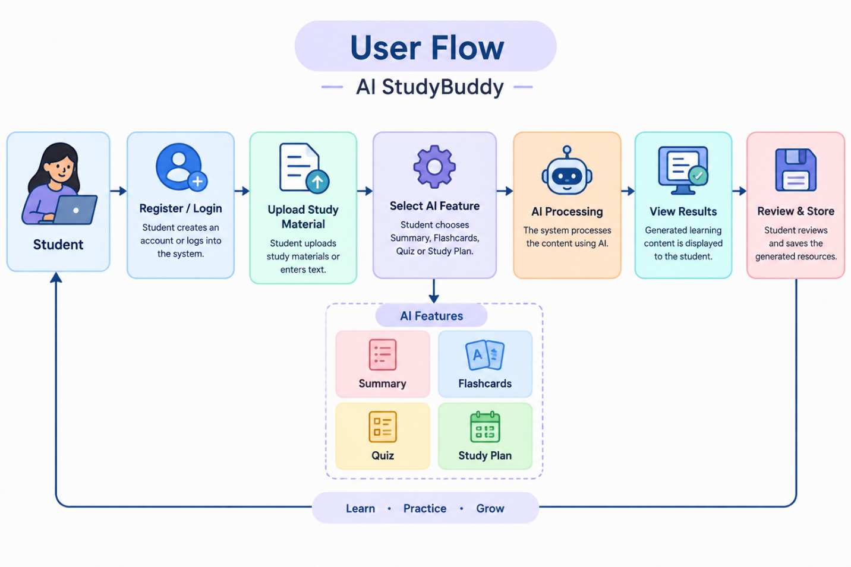

MVC Architecture Pattern
The MVC (Model–View–Controller) Architecture Pattern divides the application into three main components: Model, View, and Controller. This separation makes the system easier to develop and maintain.
1. Model
- Represents the data and database of the application.
- Uses Mongoose to interact with MongoDB.
- Manages data such as users, study materials, summaries, flashcards, quizzes, and study plans.
2. View
- Represents the output shown to the user.
- In this project, the backend provides JSON API responses.
- These responses are used by the React.js client.
3. Controller
- Handles user requests and application logic.
- Manages authentication and database operations.
- Communicates with the Gemini AI service to generate learning content.
MVC Flow
User → View (React.js) → Controller → Model → MongoDB
Epic 2: Project Setup and Configuration
Creating the Project Folder
The first step in setting up the AI StudyBuddy project is to create a separate project folder. This folder is used to store all the backend files, configuration files, source code, and other project resources.
Steps:
- Create a new folder on your computer.
- Give the folder a suitable name, such as AI-StudyBuddy.
- Open the folder in Visual Studio Code (VS Code).
- Open the terminal inside the project folder.
- Initialize the Node.js project using:
Project Initialization
- Create the project folder.
- Initialize the Node.js project using npm init -y.
- Install the required dependencies.
- Configure the project for backend development.
Create the Following Files
After creating the AI-StudyBuddy project folder, create the following important files:
- index.js – Main entry point of the backend application.
- .env – Stores environment variables such as PORT, MONGO_URI, JWT_SECRET, and GEMINI_API_KEY.
- package.json – Contains project information, dependencies, and scripts.
- .gitignore – Specifies files and folders that should not be included in version control.
Project structure:
AI-StudyBuddy/
│
├── index.js
├── .env
├── package.json
└── .gitignore
Environment Configuration
Environment configuration is used to store important project settings and secret values separately from the source code. In the AI StudyBuddy project, these values are stored in the .env file.
PORT=5000
MONGO_URI=your_mongodb_connection
JWT_SECRET=your_secret_key
GEMINI_API_KEY=your_gemini_api_key
Epic 3: Backend Development
focuses on developing the backend of the AI StudyBuddy application. The backend is built using Node.js, Express.js, and MongoDB. It provides APIs, handles authentication, manages data, and connects the application with the Gemini AI service

Backend Structure
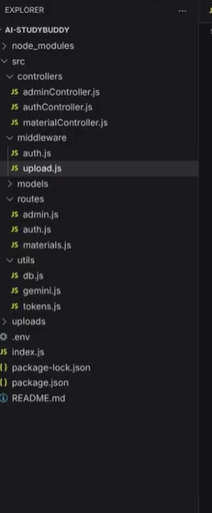
│

Core System Script Implementations
The Core System Script Implementations section describes the main backend scripts used to run the AI StudyBuddy system. The project uses Node.js and Express.js, with separate scripts for database connectivity, authentication, AI integration, and file handling.
1. index.js – Main Server Script
- Acts as the main entry point of the backend.
- Initializes the Express application.
- Loads required configuration and middleware.
- Starts the backend server.
- Connects the application components together.
2. db.js – Database Connection
- Establishes a connection between the application and MongoDB.
- Uses Mongoose for database communication.
- Ensures that the database is available before performing data operations.
3. auth.js – Authentication
- Handles user authentication.
- Uses JWT (JSON Web Token) for secure authentication.
- Helps protect routes that require logged-in users.
- Works with password hashing using bcryptjs.
4. gemini.js – AI Integration
- Connects the application with Google Gemini AI.
- Uses the Gemini API to process study content.
- Supports AI-generated features such as summaries, flashcards, quizzes, and study plans.
- The project uses Google Gemini 2.5 Flash for AI processing.
5. upload.js – File Upload
- Handles uploaded study materials.
- Uses Multer for file-upload processing.
- Performs file validation before the material is processed.

Configure MongoDB
- In the AI StudyBuddy project, MongoDB is used to store application data, while Mongoose is used to connect the Node.js backend with MongoDB.
Steps to Configure MongoDB
- Install MongoDB
  - Install MongoDB on the system or use MongoDB Atlas.
- Create a Database
  - Create a database for the AI StudyBuddy application.
  - Example database name: ai-studybuddy
- Install Mongoose
npm install mongoose
- Create Database Configuration
The db.js file is used to establish the connection between the backend and MongoDB.
Mongoose Schema Definitions
1. User Schema (models/User.js)
The User Schema defines the structure of user information stored in the MongoDB database. It is created using Mongoose and is used to manage both Student and Administrator account
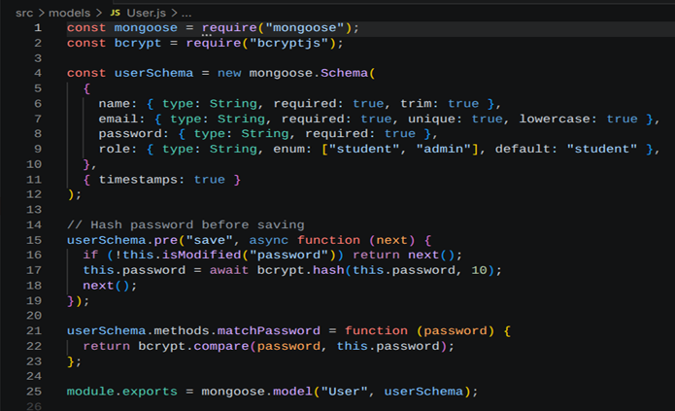
2. Study Material Schema (models/Material.js)
The Study Material Schema defines the structure used to store the learning materials uploaded or entered by a student. It connects each study material with the user who created it.
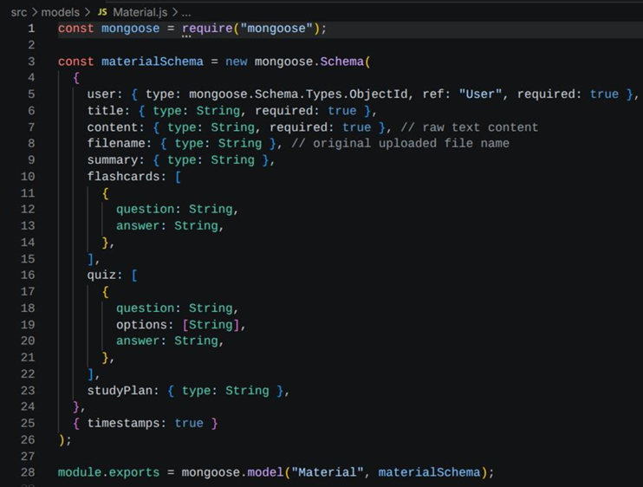

API Route Interface / Endpoints
- User Authentication – User registration and login are handled through API routes.
- Study Material API – Allows users to add and retrieve study materials.
- Summary API – Generates and manages AI-based summaries.
- Flashcard API – Creates and retrieves revision flashcards.
- Quiz API – Generates quizzes from study materials.
- Study Plan API – Creates and manages personalized study plans.
- RESTful Communication – Provides communication between the frontend and backend.
- JSON Response – Sends processed data from the backend to the frontend.
- API Testing – APIs can be tested using Postman.
Project Execution
the process of running, testing, and verifying the complete AI StudyBuddy application after the project setup, backend development, database configuration, and API implementation are completed. The execution phase ensures that all major components work together correctly.
API Testing
API Testing is the process of checking whether the backend APIs of the AI StudyBuddy application work correctly. The APIs can be tested using Postman by sending requests to the backend and checking the responses.
Main Testing Points
- Registration API – Checks whether a new user can register successfully.
- Login API – Verifies user authentication.
- Study Material API – Tests adding and retrieving study materials.
- Summary API – Checks AI-generated summary requests.
- Flashcard API – Tests flashcard generation.
- Quiz API – Tests quiz generation.
- Study Plan API – Tests personalized study plan creation.
- Authentication Testing – Verifies protected API access.
- Response Testing – Checks whether the API returns the expected response.
- Database Testing – Verifies that required data is correctly stored and retrieved from MongoDB.

API Testing
The backend APIs can be tested using postman.

1.User Registration
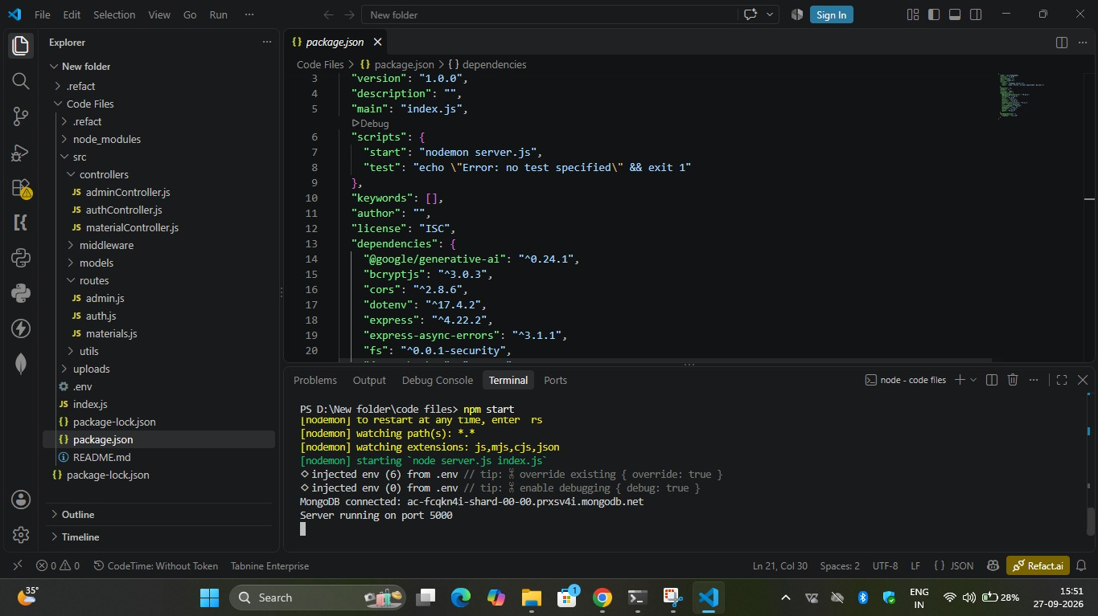

2. User Login
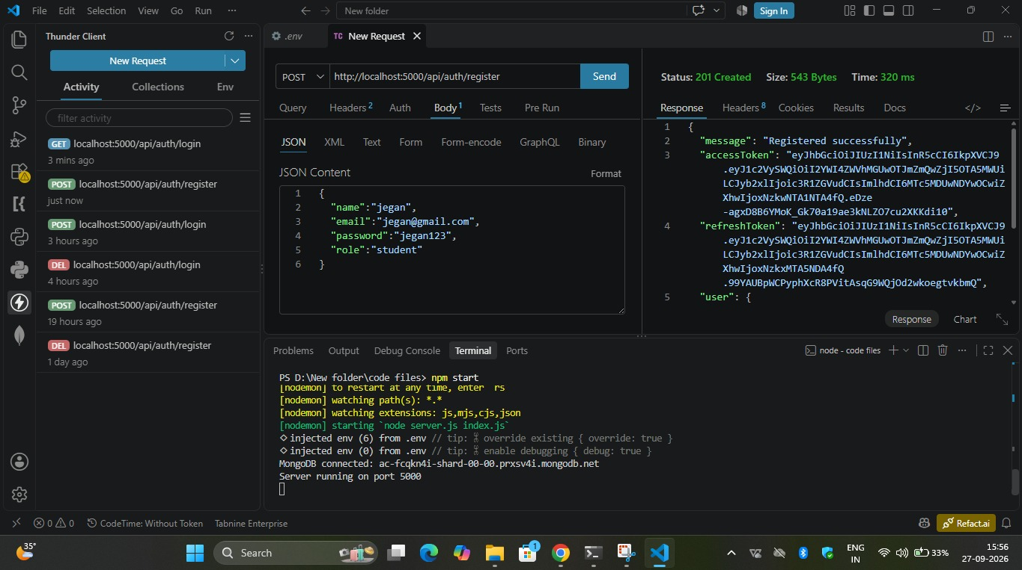

3. Upload Study Material
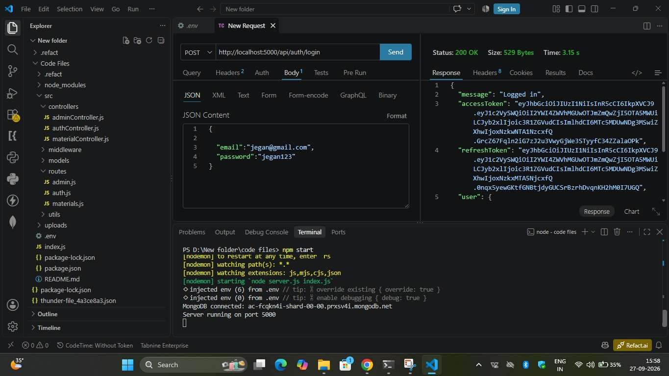

4. Generate AI Summary
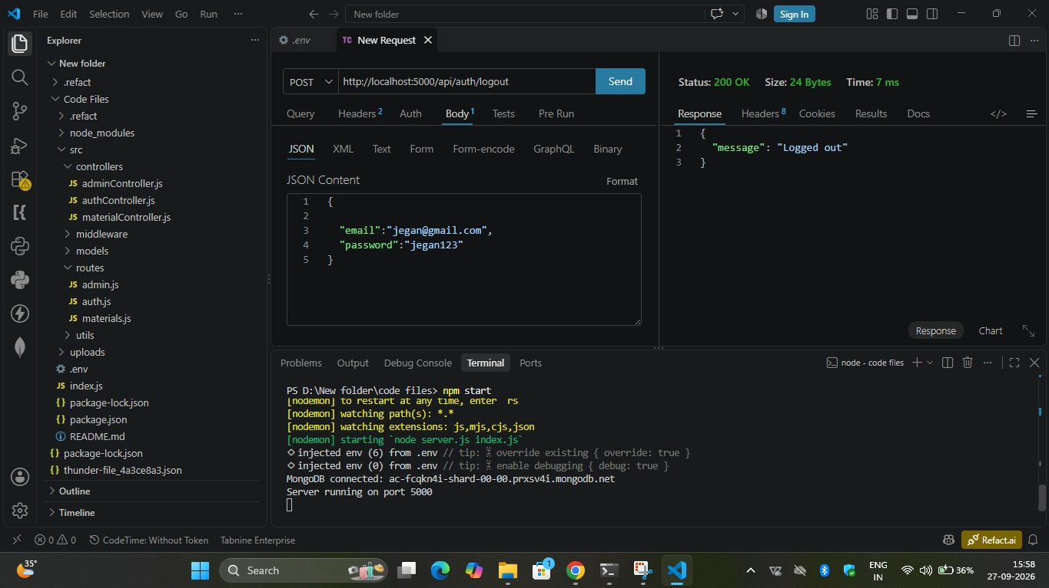

5. Generate AI Flashcards
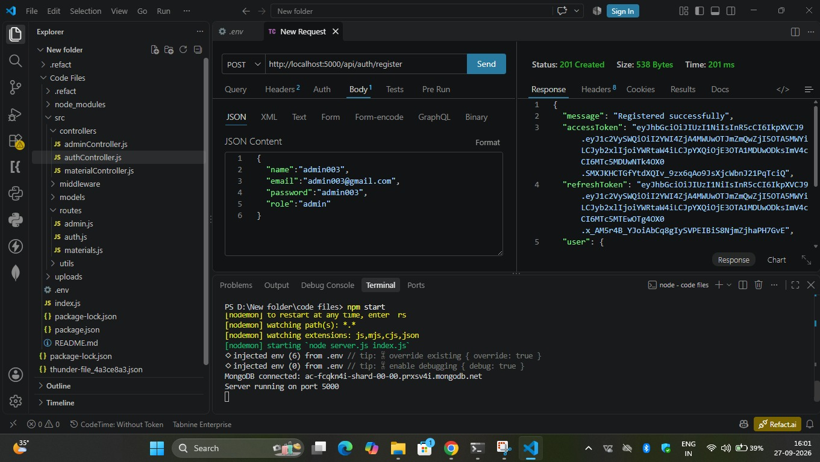

6.Generate AI Quiz
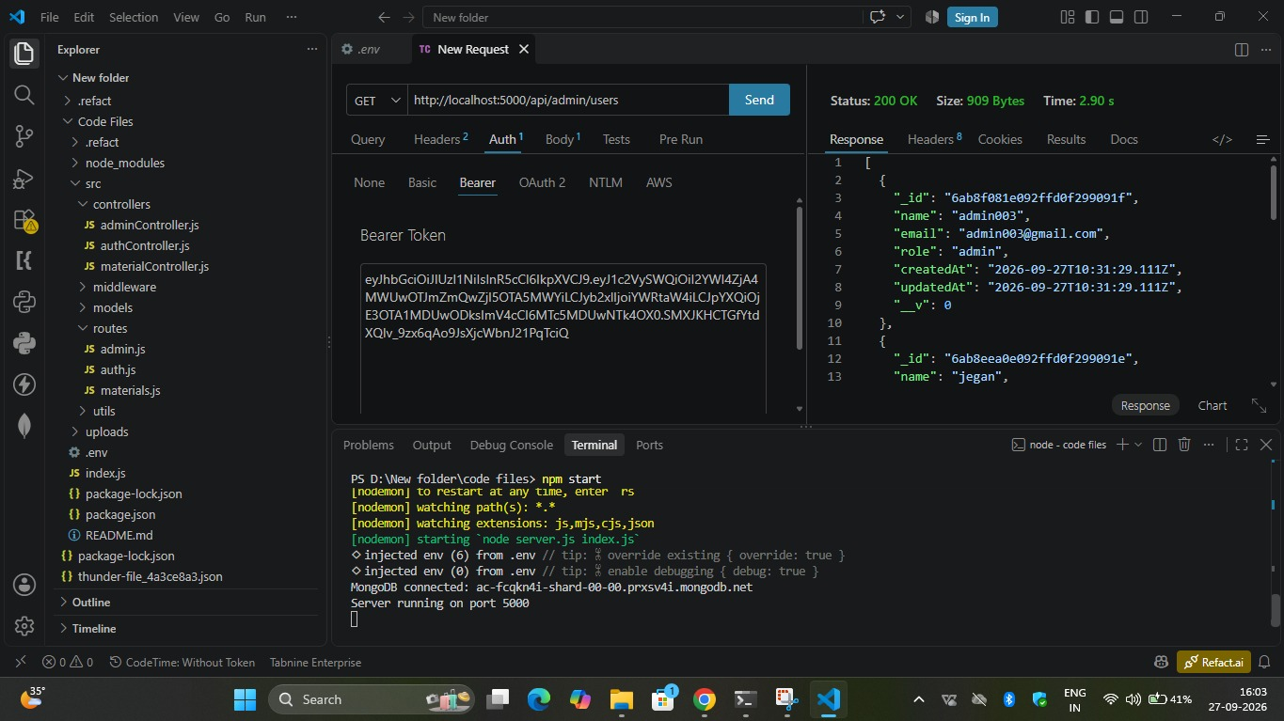

7.Generate AI Study Plan
